**Challenge:**

**Make a dynamic chart to show COVID-19 deaths per country vs. a list of predictions**

As we are amidst the largest pandemic in recent history, why not make the task to create an interactive chart (mockup below) to be able to see per country the cumulative deaths per day.

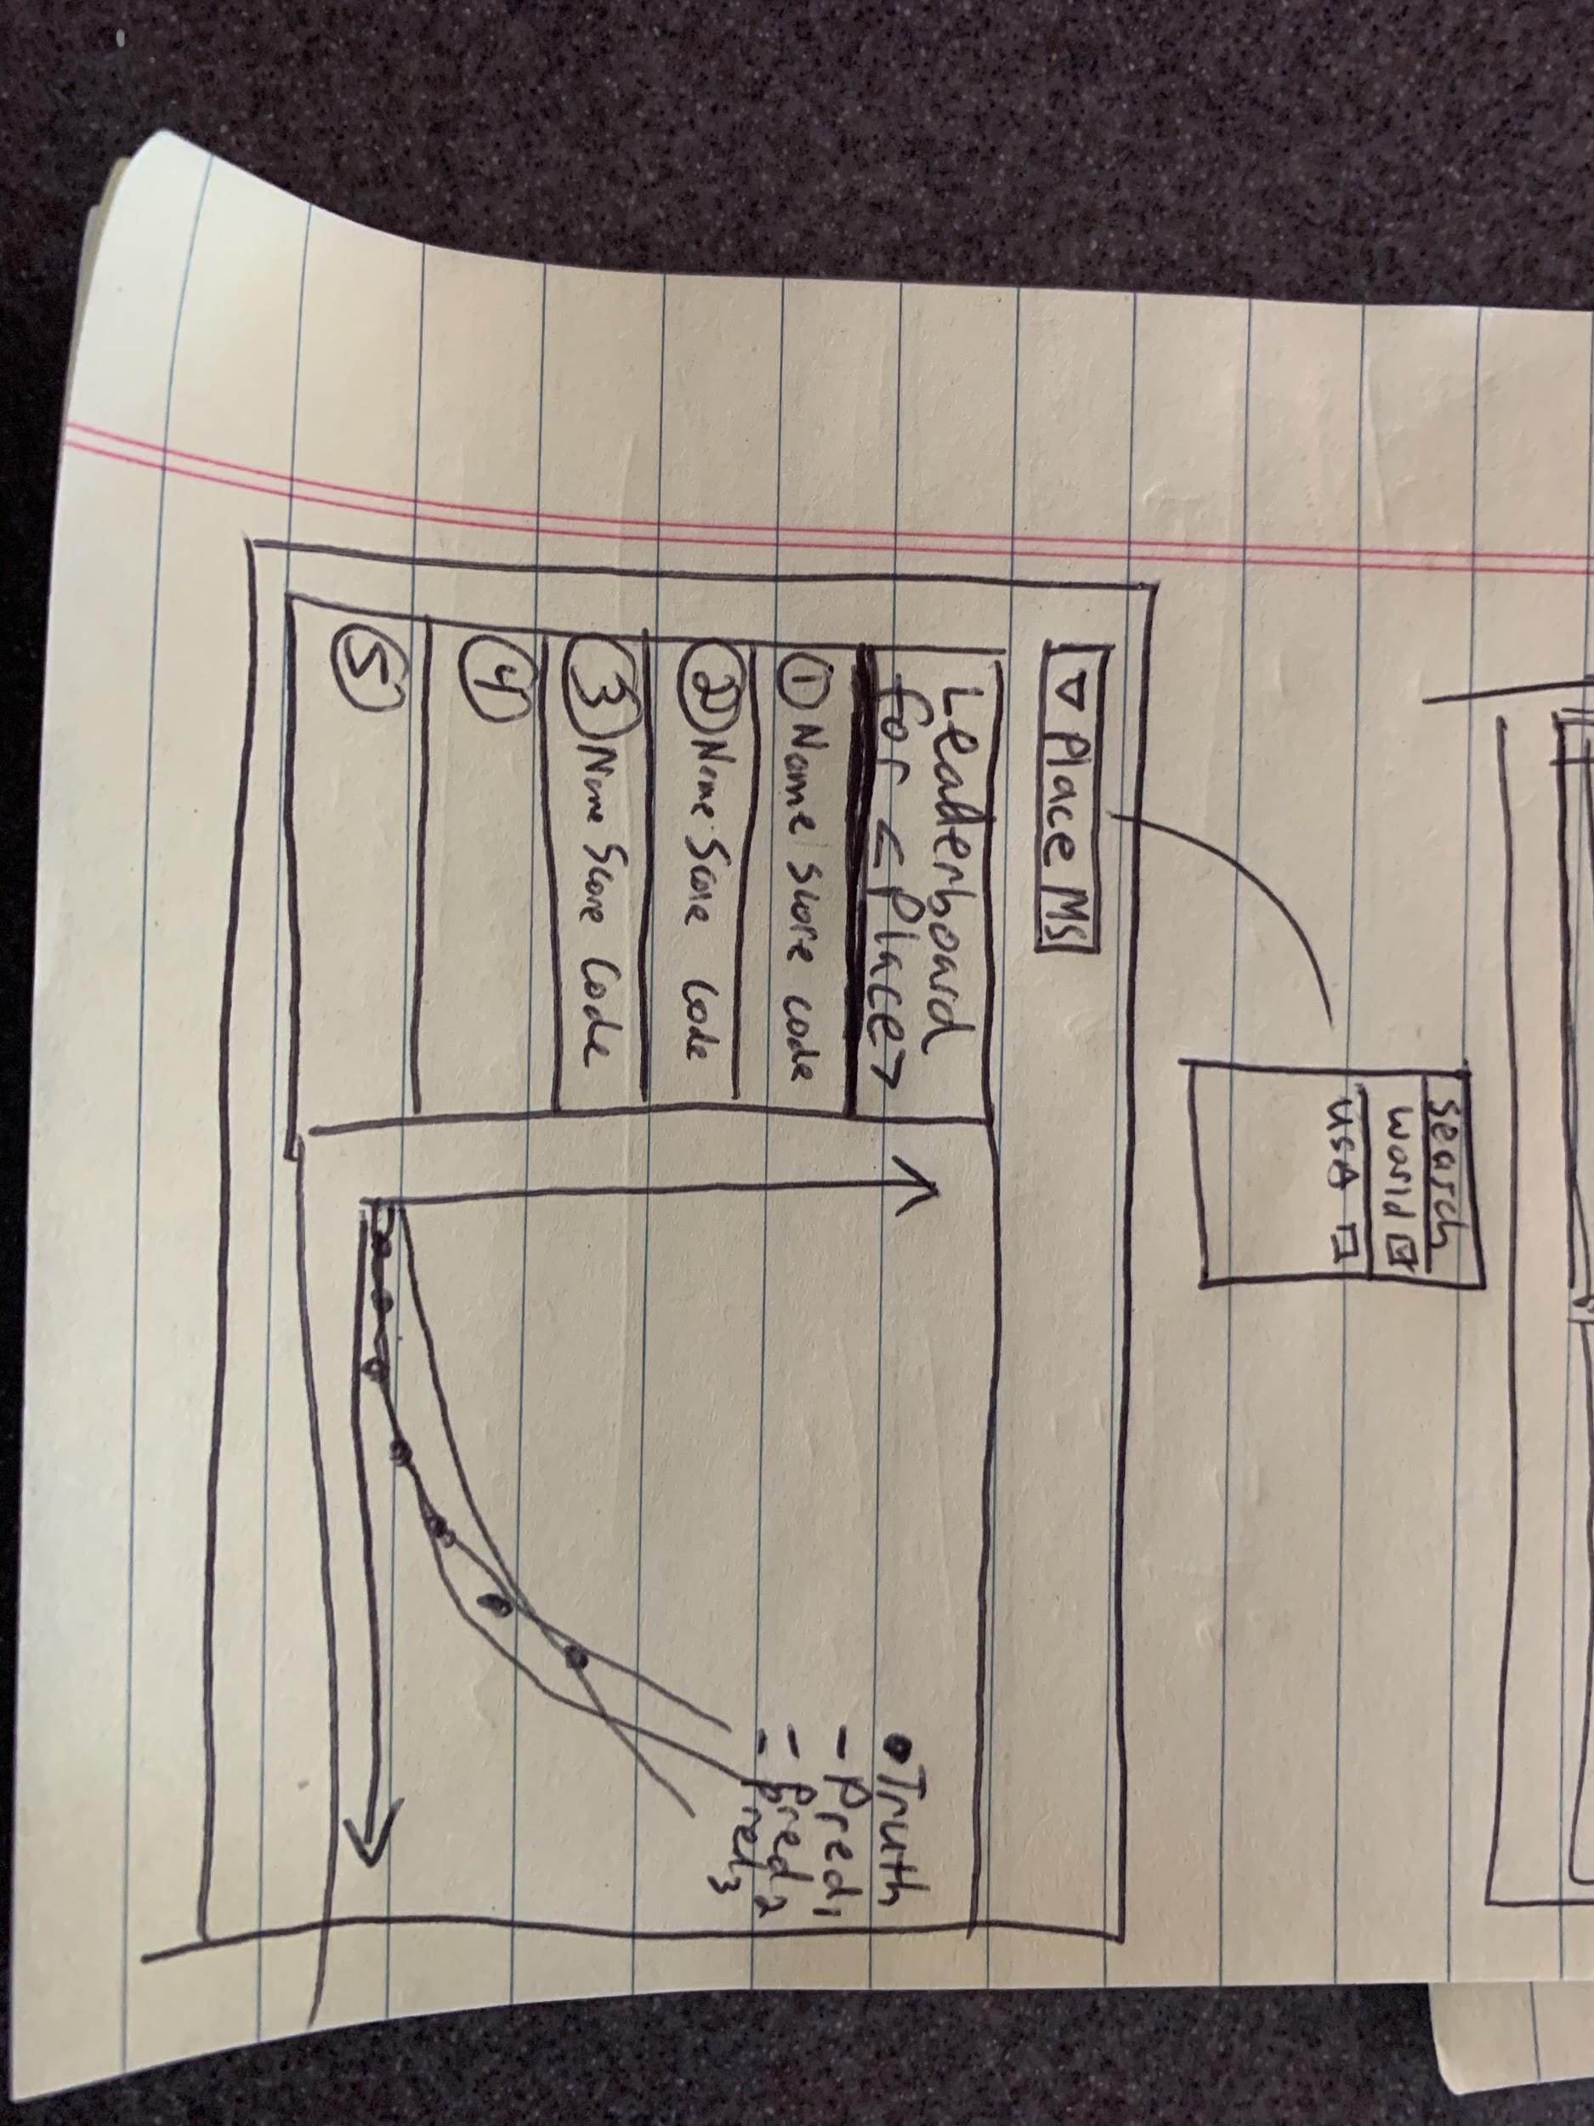

If you look [here](https://drive.google.com/drive/folders/1nja0wnh3dvKWKycCetOX3OGPmj7wcpDM), you will see all the files you need. There are 3:

1. time_series_covid19_deaths_global.csv
   1. This file has the most recent death data from the World Health Organization.
   2. This file, column 1, is where the "Place" Dropdown values (only one can be clicked at any one time) should be pulled from.
2. leaderboard.json
   1. This holds a json array with scores for each prediction for each "Place". It also has metadata in there for each submission. The keys are the names of the folders to look up in the prediction_challenge/ folder to get the predictions.csv's.
3. predictions_challenge.zip
   1. This holds the underlying data for the scores which should be plotted to the right when the user clicks on the prediction row and toggles on/off appropriately. The structure is:
      1. submissionid/
         1. metadata.json (this holds the metadata about the submission.. roughly you can ignore this, unless you find that data useful)
         2. predictions.csv (this holds the timeseries predictions for each place. WARNING: Not everyone submits predictions for every place.)

Requirements:

1. On loading the .html from a directory, all files should load from the relative dir ./
2. The Place Dropdown should have only "World" turned on. The left hand "Leaderboard" side should show the top 5 submissions ranked by score for "World" from the leaderboard.json. Include as much data as you want per row, such as the email_address, the date of submission from the meta_data, the source_code, the score, etc. If there are not 5, then show what you have. The chart on the right, should be populated with the "World" place, and should show the best 3 predictions against "World" as per the score, if not 3, then show what you have. The user should be able to click each row, or otherwise if you think of a better idea, to turn on and off truth and any or all of the predictions.
3. When the user drops down the "Place" Dropdown and selects a new place, the leaderboard should clear and update with the scores for that place, and the right chart should show the corresponding predictions for the place and the truth data should show for the place. The truth and the prediction should be able to be toggled on and off.
4. x-axis should show dates.
5. y-axis should show values in "deaths".
6. Plot should be able to pan and zoom in and out easily.
7. Must add a "log" checkbox that will change the plot's y-axis to be log scale on/off. Can be near the "Place" Dropdown. Should affect all time series.
8. Must add a "dy/dx" checkbox that will change the plot to be the "change" from ti to ti+1 for every time series. User should be able to toggle on/off. Can be near the "Place" Dropdown. Should affect all time series including truth and the predictions.
9. You should be able to read these files directly in via js and not make any new file formats or caching, etc. No other files can be a part of the submission package.
10. Use pure javascript/jquery only, no typescript / coffeescript / etc. Do not "minimize" your js so we can inspect code quality.
11. Code should be a link to go to where the source code is.

Nice to haves:

1. It is recommended that you use Plot.ly but if you know of a better plotting framework that is fine.
2. Should be very fast / intuitive.
3. No typos.
4. Color scheme however you'd like, but should look good.
5. Should present well on web and mobile.
6. Must be able to run on my local without any npm or other installations/dependencies.

Extra Credit:

1. Add any other cool features you'd like!
2. Adding a running time play button like this.
3. Making *some* type of use of the lat / long! We will let you run with that if you want.

We do not want you spending more than 3 hours on this so you can get it done this week and we can get you started at Focal next week. So do not feel too pressured to do any of the extra credit, that is more just if you have the extra bandwidth. (Note, I am just finishing my own version of this so I want to see how you would do it as well!)